Rwanda DPA Compliance for Log360
Strengthen data protection and meet Rwanda DPA compliance with Log360.
Region: Rwanda | Type: Data Privacy | Category: Compliance | Pricing: Free

Overview
The Rwanda DPA compliance extension in Log360 helps organizations meet Law No. 058/2021 Relating to the Protection of Personal Data and Privacy, Rwanda's data protection law supervised by the National Cyber Security Authority requiring consent-based processing, data subject rights, and 48-hour breach notification by providing centralized log management, file access auditing, and security event monitoring. The platform supports Rwanda DPA requirements for consent accountability, data subject rights, data security, breach notification, processing records, cross-border transfer controls, and data retention.
For Lawful Basis and Consent Accountability, Log360 tracks user account changes, AD logon records, and computer auditing events to maintain accountability over who accesses personal data systems. To address Data Subject Rights Management, the platform monitors user management, Entra ID user changes, group modifications, and account management events to track fulfillment of data subject rights. The extension also supports Data Security and Technical Safeguards by providing capabilities that monitors file changes, SharePoint and OneDrive file activities, S3 operations, and USB storage events to enforce data security and detect unauthorized access.

Key Features
- Data Breach Detection and Notification: Log360 aggregates Windows threat detection, FireEye, Entra ID risky sign-ins, network attack reports, and Unix threat events to enable rapid breach detection and response.
- Record-Keeping and Processing Accountability: Log360 centralizes EventLog, GPO auditing, database audit, computer auditing, and AD logon records to provide complete processing audit trails.
- Cross-Border Data Transfer Controls: Log360 monitors AWS user activity, IAM operations, VPC traffic, S3 file transfers, and cloud storage integration events to detect and audit cross-border data flows.
- Data Retention and Erasure Management: Log360 tracks file changes, cloud storage file activities, MSSQL and DB2 DDL changes, and SharePoint operations to monitor compliance with retention and erasure obligations.
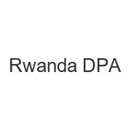
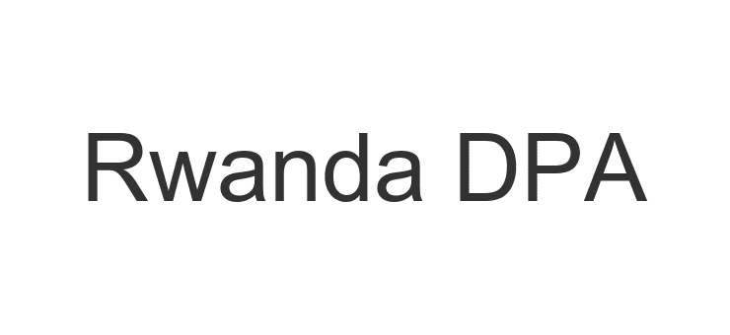
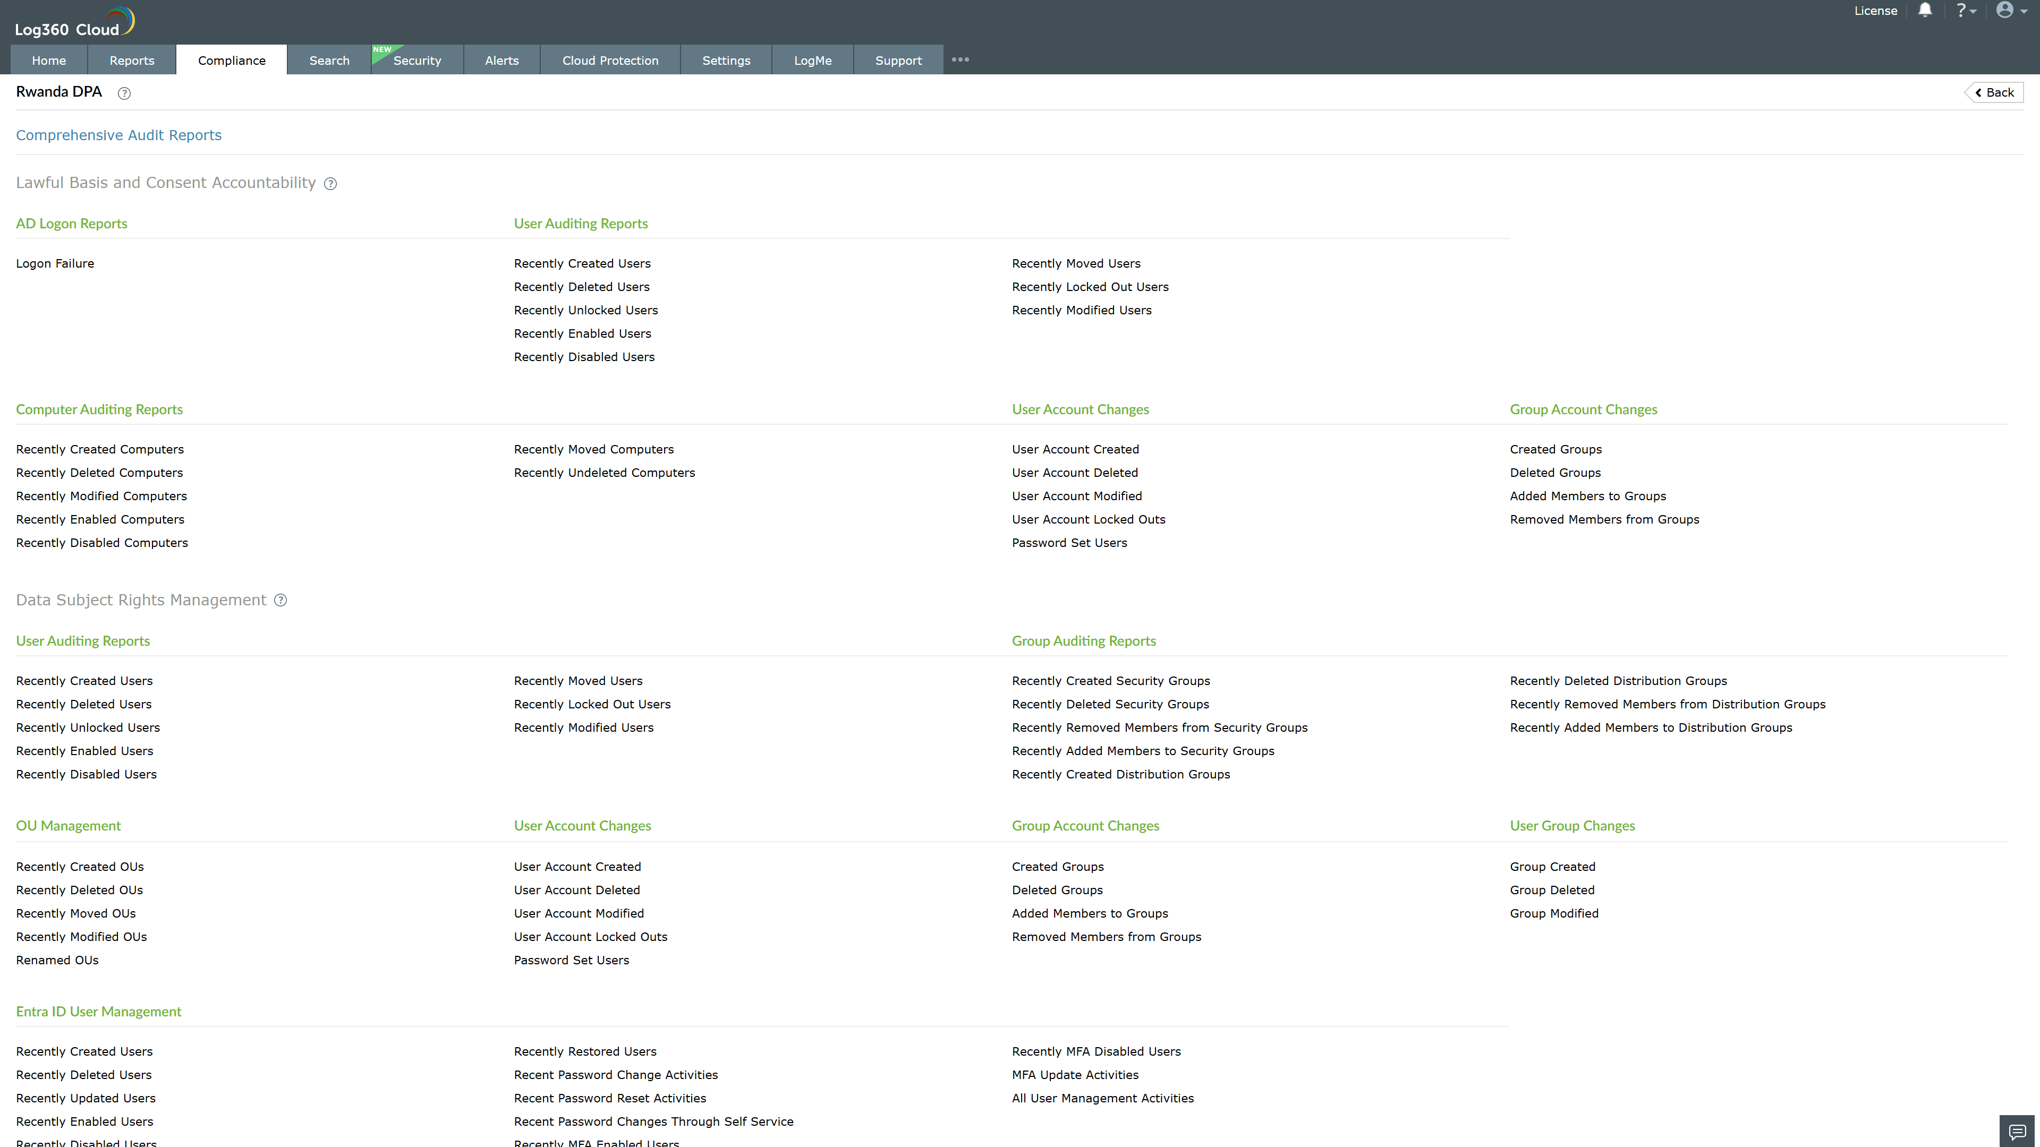
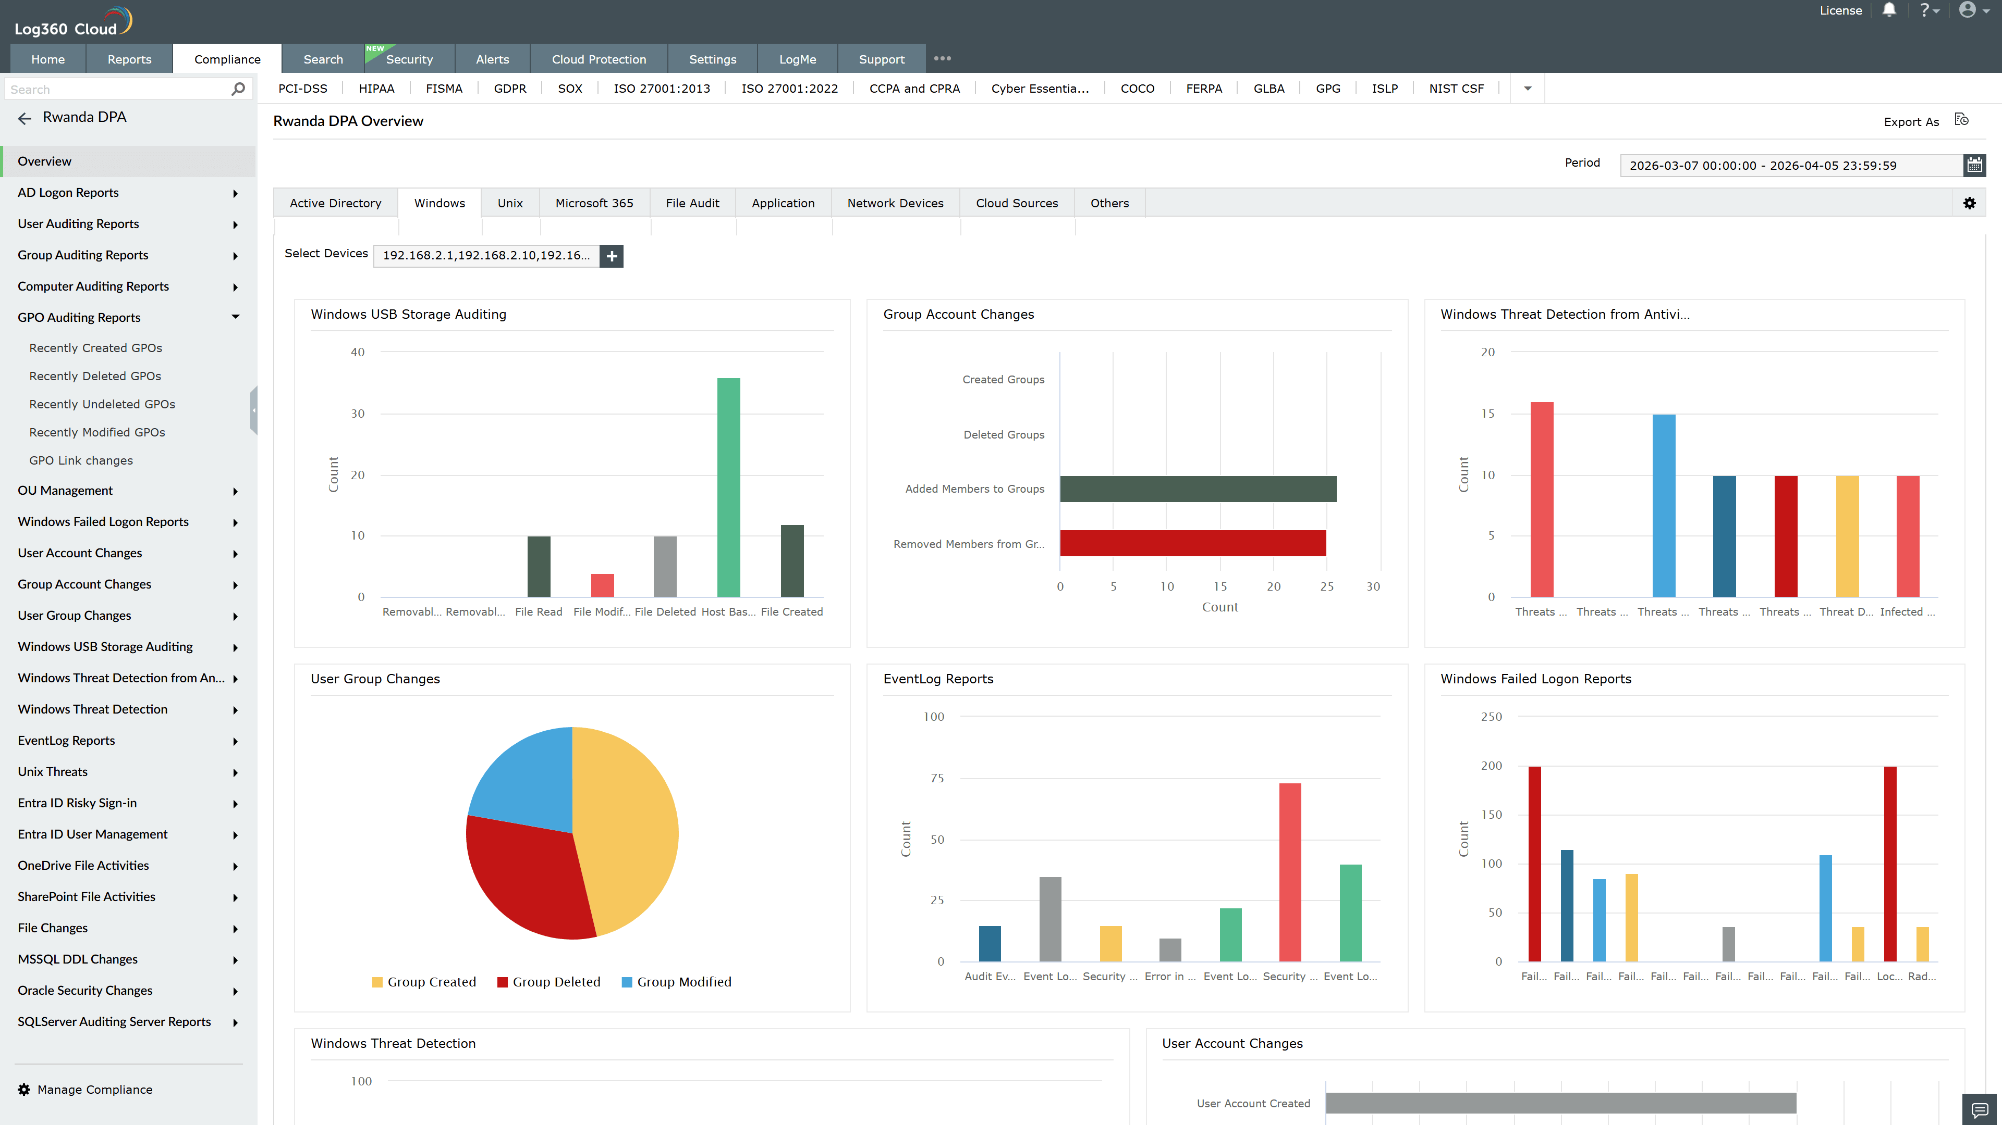
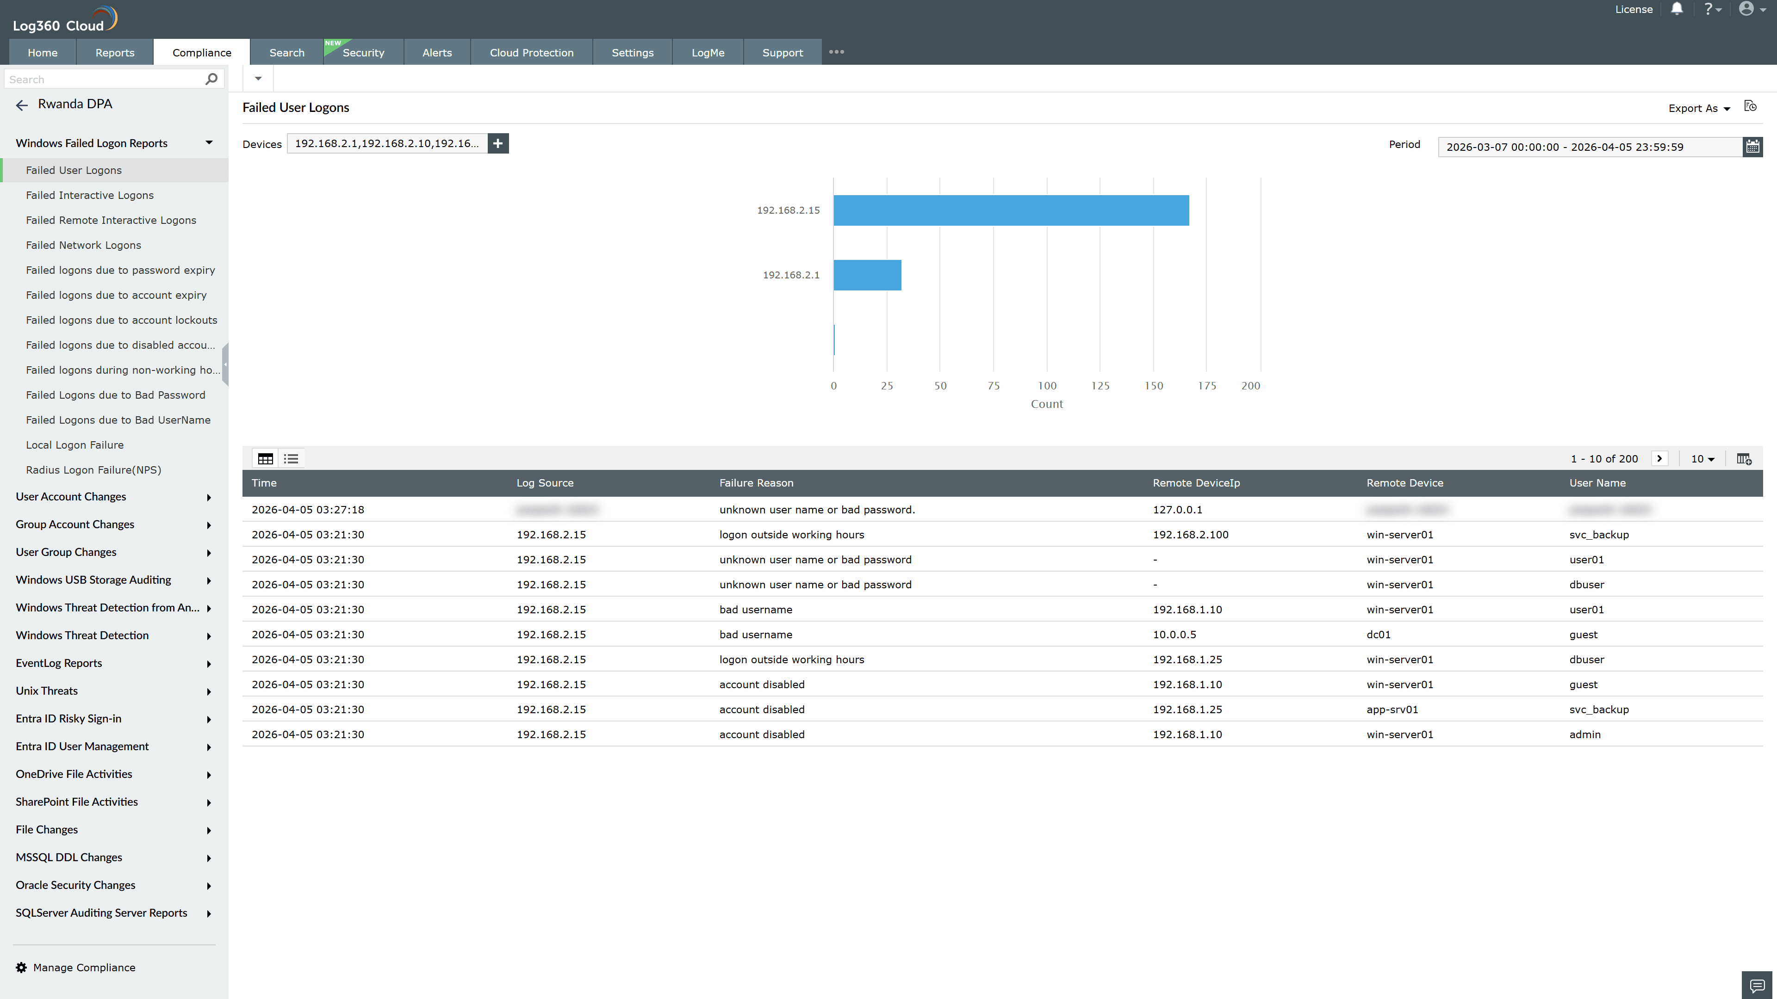
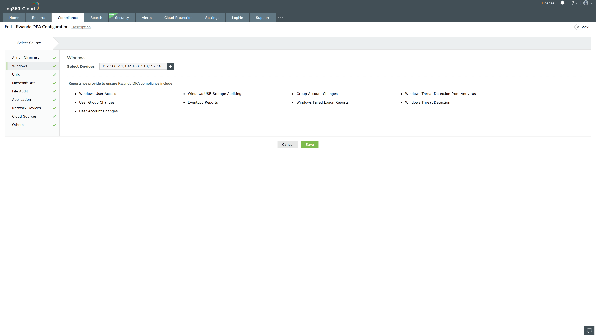
Valid Submission : Yes
Supported Editions : Free, Basic, Standard, Professional, MSSP
Help Document : https://www.manageengine.com/log-management/help/integrations/compliance-extensions.html
Help Video : Not provided
Tags : Log360, Compliance, Privacy monitoring, Data privacy, Regulatory compliance
Supported DCs : US, IN, JP, CA, AU, UK and EU
Privacy Policy:
Terms of Service:
Release Notes:
Predefined reports for the Rwanda DPA.

